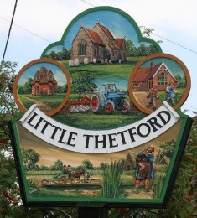
Little Thetford Parish Council
Chairman: Cllr C Mitchell
Clerk: Mrs A Jacklin, The Village Hall, The Wyches, Little Thetford, CB6 3HG
07828402093 parish.clerk@littlethetford.org.uk

LOCAL GOVERNMENT ACT 1972
NOTICE OF VACANCY IN
THE OFFICE OF PARISH COUNCILLOR

NOTICE IS HEREBY GIVEN pursuant to section 87(2) of the Local Government Act 1972 that Mrs Alison Kilby formerly a member of the above Parish Council has ceased to be a member and that a casual vacancy exists in the office of Councillor for the said Parish.

On receipt of a request in writing from any 10 local government electors for the said Parish, an election to fill the vacancy will be held in May 2023. If no such request is made the vacancy will be filled by co-option by the Parish Council.

Requests for such an election should be addressed to:

The Returning Officer
East Cambridgeshire District Council
The Grange
Nutholt Lane
Ely
CB7 4EE

Requests to arrive not later than Monday 25th July 2022
(14 days* from the date of this notice)

*In computing any period of time for this purpose, a Saturday or Sunday, Christmas Eve, Christmas Day, Maundy Thursday, Good Friday or a Bank Holiday or a day appointed for public thanks giving or mourning are disregarded.

Dated: Monday 4th July 2022

Signed:
Mrs Amy Jacklin
Clerk and Proper Officer – Little Thetford

