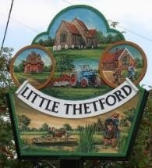
Little Thetford Annual Parish Meeting
Chairman: Cllr C Mitchell
Clerk- Mrs Amy Jacklin, c/o Little Thetford Village Hall, The Wyches, Little Thetford CB6 3HG 07828 402 093 parish.clerk@littlethetford.org.uk

Parishioners, members of the public and the Press are welcome to attend.
Tuesday 26th April 2022 @7pm at the Village Hall, Little Thetford.

Wednesday 20th April 2022 Mrs Amy Jacklin Clerk to Little Thetford

AGENDA

- Introduction by the Chairman
- Apologises for absence received.
- Little Thetford Parish Council
Annual report from the Chairman of the Parish Council. Questions on the Parish Council and Committee business will be taken by the Chairman.
- ‘One Little Thetford’
Chairman to talk about this year’s topic
- Parish Council Accounts
Parish Council accounts 2020/21- Audited.
Parish Council accounts 2021/22- Subject to Audit.
- Representatives from the following Organisations will be present to give reports and answer questions.
East Cambridgeshire District Council- Cllr Bill Hunt
Little Thetford Village Hall- Richard Church
John Townsend Charity- Jenny Staines
- Reports from Clubs and other organisations
- Open Forum.

